Exp No : 4
7 SEGMENT DISPLAY USING AT89C51 USING PROTEUS
AIM: To write an assembly language program for 7 Segment Display Using AT89C51 using Keil and Proteus
SOFTWARE REQUIRED: Proteus 8 software.
PROGRAM:
ORG 000H
UP: MOV P2,#0C0H
ACALL DELAY
MOV P2,#0F9H
ACALL DELAY
MOV P2,#0A4H
ACALL DELAY
MOV P2,#0B0H
ACALL DELAY
MOV P2,#99H
ACALL DELAY
MOV P2,#92H
ACALL DELAY
MOV P2,#82H
ACALL DELAY
MOV P2,#0F8H
ACALL DELAY
MOV P2,#80H
ACALL DELAY
MOV P2,#90H
ACALL DELAY
DELAY: MOV R5,#10
H1: MOV R4,#180
H2: MOV R3,#255
H3: DJNZ R3,H3
DJNZ R4,H2
DJNZ R5,H1
RET
END
OUTPUT :
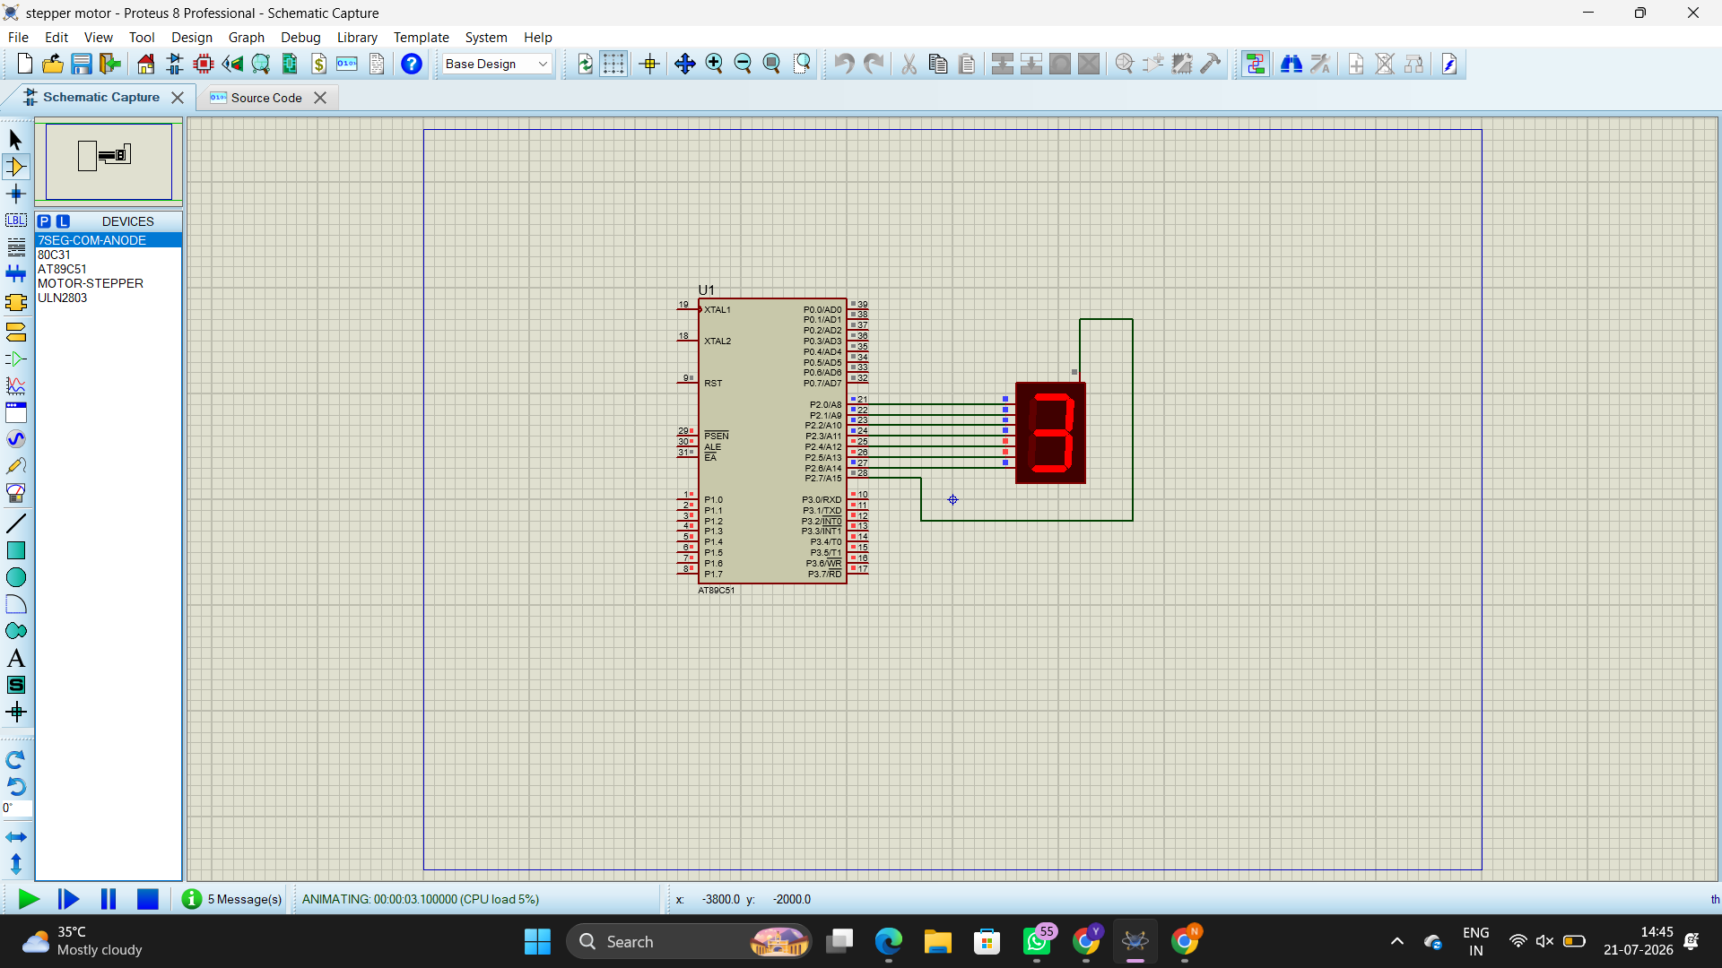

RESULT :
Thus the program has been successfully verified and executed

